View the Lesson (Introduction to HTML)

What is the HTML

HTML stands for **H**yper**T**ext **M**arkup **L**anguage.

* A **markup language** defines the structure and presentation of raw text.
* A **HyperText** is text displayed on a computer or device that provides access to other text through links (hyperlinks).

**HTML** is a markup language used to create documents on the web. It describes the structure and layout of a web page.

View the Lesson (Introduction to HTML)

History of HTML

**HTML** was originally developed by Tim Berners-Lee while at CERN. While working at CERN, he became frustrated at having to log on to different computers to find different information and thought that there must be a better way. He figured that there must be a way to hop from one set of information to another that's on different computers. This concept of a hypertext system (connected with the networking technology and protocols needed to pass information between computers) would go on to form the basis for the fundamental language of the world wide web. HTML is a very evolving markup language and has gone through several changes since its inception.

| **Version** | **Year** |
| --- | --- |
| HTML | 1991 |
| HTML 2.0 | 1995 |
| HTML 3.2 | 1997 |
| HTML 4.01 | 1999 |
| XHTML | 2000 |
| HTML5 | 2014 |

## View the Lesson (Introduction to HTML)

### HTML Page Structure

* The <head> element contains metadata about the page. HTML metadata is data about the HTML document and metadata is not displayed. Metadata typically defines the document title, character set, styles, scripts, and other meta information.
* The <body> element indicates what should appear in the main browser window.

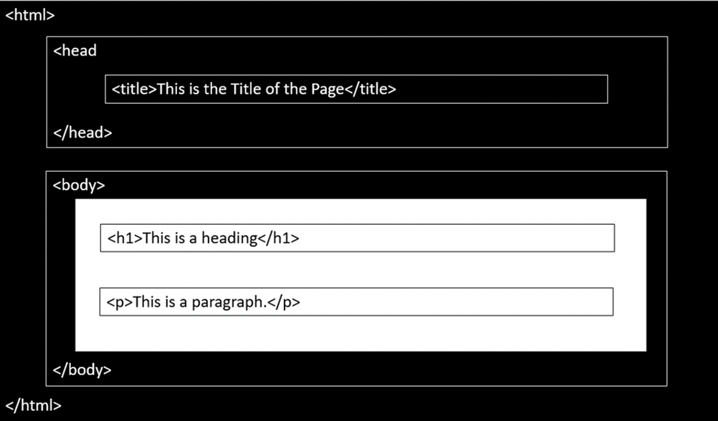

### A Simple HTML Document

<!DOCTYPE html>

<html>

<head>

<title>Page Title</title>

</head>

<body>

<h1>This is a Heading</h1>

<p>This is a paragraph.</p>

</body>

</html>

Output:

# **This is a Heading**

This is a paragraph.

**Explanation of HTML Document:**

* The <!DOCTYPE html> declaration defines this document to be HTML5.
* The <html> element is the root element of an HTML page.
* The <head> element contains meta information about the document.
* The <title> element specifies a title for the document.
* The <body> element contains the visible page content.
* The <h1> element defines a large heading.
* The <p> element defines a paragraph.

View the Lesson (HTML Elements and Tags )

HTML Elements

HTML is composed of elements. HTML uses these elements to describe the structure of pages. A tag and the content between it is called an **HTML element**. Elements are usually made up of two tags: An **opening tag** and a **closing tag**. The opening tag is also called the starting tag, and the closing tag is called the end tag. Each HTML element tells the browser something about the information that is between its opening and closing tags.

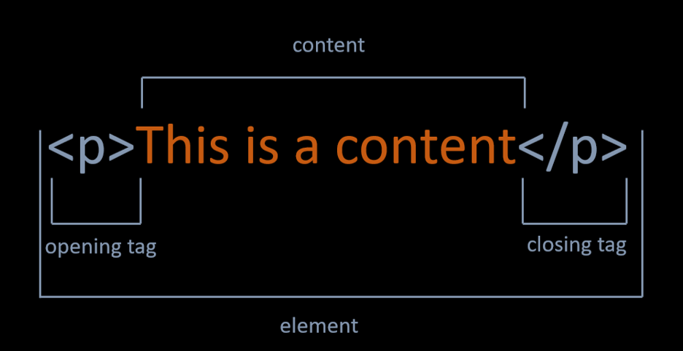

You can find all elements used in HTML by following this [link.](https://www.w3schools.com/tags/default.asp)

### Nested HTML Elements

HTML documents consist of nested HTML elements. HTML elements can contain elements (elements can be nested). All HTML documents composed of nested HTML elements.

<!DOCTYPE html>

<html>

<body>

<h1>This is a Heading</h1>

<p>This is a paragraph.</p>

</body>

</html>

# **This is a Heading**

This is a paragraph.

HTML Document above contains four HTML elements.

* The HTML element includes the body element.
* The body element includes the h1 and p elements.

### Empty HTML Elements

* If a HTML element does not have any content, it is called empty element.
* Empty HTML elements do not have a closing tag.
* For example, <br> and <img> elements are empty elements.
* You will learn more about elements in this course.

## View the Lesson (HTML Elements and Tags )

### HTML Tags

* **HTML tags** are element names surrounded by angle brackets. The element name indicates the tag's purpose. For example, p stands for paragraph.
* The opening tag denotes the start of a piece of content. The opening tag is composed of the left-angle bracket, element name, and right-angle bracket.

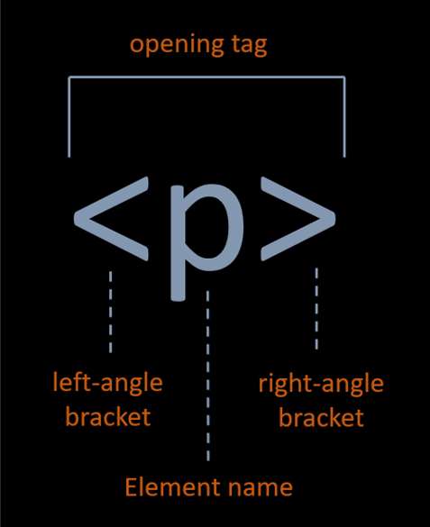

* the closing tag denotes the end of an HTML element. The closing tag is composed of the left-angle bracket, forward slash, element name, and right-angle bracket.

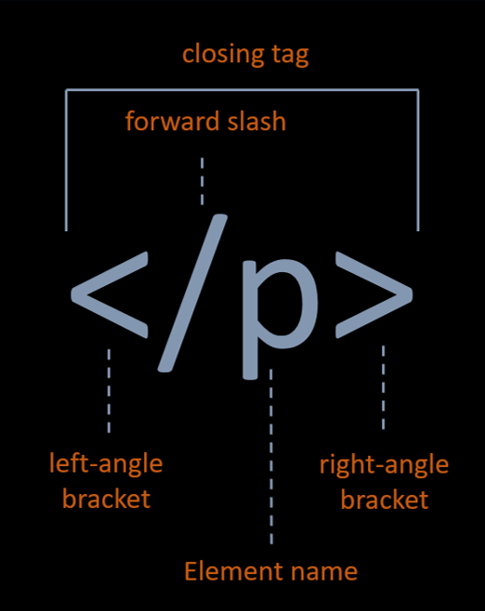

HTML Div Tag

A <div> section in a document that is styled with CSS:  
  
The <div> tag defines a division or a section in an HTML document.  
  
The <div> tag is used as a container for HTML elements - which is then styled with CSS or manipulated with JavaScript.  
  
The <div> tag is easily styled by using the class or id attribute.  
  
Any sort of content can be put inside the <div> tag!  
  
Note: By default, browsers always place a line break before and after the <div> element.

HTML Attributes

Attributes provide additional information about the contents of an element. Attributes are always specified in the opening tag and are made up of two parts: a name and a value, separated by an equals sign. For example, The style attribute is used to specify the styling of an element, like color, font, size etc.

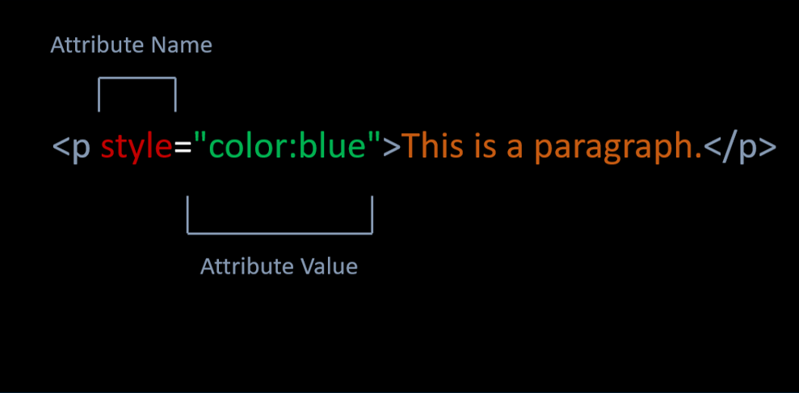

## View the Lesson (HTML Text)

### HTML Headings

Headings are used to describe content, like the title of an article. HTML has six "levels" of headings, which are graded according to importance. Headings are defined with the <h1> to <h6> tags. <h1> defines the most important heading. <h6> defines the least important heading.

<!DOCTYPE html>

<html>

<body>

<h1>The most important heading</h1>

<h2>This is heading 2</h2>

<h3>This is heading 3</h3>

<h4>This is heading 4</h4>

<h5>This is heading 5</h5>

<h6>The least important heading</h6>

</body>

</html>

Output:

# **The most important heading**

## This is heading 2

### This is heading 3

#### **This is heading 4**

##### **This is heading 5**

###### **The least important heading**

### HTML Paragraphs

* The HTML <p> element stands for paragraph.
* Paragraph element contains blocks of text.

<!DOCTYPE html>

<html>

<body>

<p>This is first paragraph.</p>

<p>This is second paragraph.</p>

</body>

</html>

Output:

This is first paragraph.

This is second paragraph.

### Horizontal Lines

* The <hr> tag creates a horizontal line.
* The <hr> tag is displayed as a horizontal rule.
* The <hr> tag is used to separate content on a HTML page.
* <!DOCTYPE html>
* <html>
* <body>
* <h1>This is heading</h1>
* <p>Horizantal Line is below. </p>
* <hr>
* <p>Horizantal Line is above. </p>
* </body>
* </html>

Output:

# **This is heading**

Horizantal Line is below.

Horizantal Line is above

### HTML Line Breaks

* The HTML <br> tag stands for a line break.
* The <br> tag is used to add a single line break.
* The <br> tag has no end tag.
* <!DOCTYPE html>
* <html>
* <body>
* <p>This is a paragraph </p>
* <p>This is <br> a new line.</p>
* </body>
* </html>

Output:

This is a paragraph

This is  
a new line.

### HTML Comments

* Comments can add the text between these characters.

<!-- This is a comment-->

* The browser does not display comments, but with comments, we can place warnings, descriptions and other notes.
* Comments are also imported for debugging HTML. We can use comments for searching errors.

### HTML < b > Element

The <b> element is used to define bold text.

<!DOCTYPE html>

<html>

<body>

<p>This is a <b>bold</b> text</p>

</body>

</html>

Output:

This is a **bold** text

HTML < strong > Element

* The <strong> element is used to define strong text.
* The <strong> element uses for the semantic important texts.
* <!DOCTYPE html>
* <html>
* <body>
* <p>This is a <strong>strong</strong> text</p>
* </body>
* </html>

Output:

This is a **strong** text

### HTML < i > Element

The <i> element is used to define italic text.

<!DOCTYPE html>

<html>

<body>

<p>This is an <i>italic</i> text</p>

</body>

</html>

Output:

This is an *italic* text

### HTML < em > Element

* The <em> element is used to define emphasized text.
* <em> means that the text is "important".

<!DOCTYPE html>

<html>

<body>

<p>This is an <em>emphasized</em> text</p>

</body>

</html>

Output:

This is an emphasized text

### The Difference Between Bold and Strong, Emphasized and Italics.

* <strong> and <b> tags make text bold. They're identical when it comes to presentation.
* <strong> represents a span of text with strong importance. There is an important semantic meaning here. They may look the same to humans. But, when a search engine spiders and analyzes a page, text in <strong> tags is considered important. Text in <b> tags is not.
* Just like <strong> and <b>, <em> and <i> are identical in terms of presentation. They both make text italic. There is no semantic meaning for <i> tag. But, <em> tag represents a span of text with emphatic stress like <strong> tag.

### HTML < small> Element

The <small> element is used to define smaller text.

<!DOCTYPE html>

<html>

<body>

<p>This is a <small>smaller</small> text</p>

</body>

</html>

Output:

This is an smaller text

### HTML < sup > Element

The <sup> element is used to define superscript characters such as the suffixes of dates.

<!DOCTYPE html>

<html>

<body>

<p>Today is 15<sup>th</sup> of february.</p>

</body>

</html>

Output:

Today is 15th of february.

### HTML < sub > Element

The <sub> element is used to define subscripted text.

<!DOCTYPE html>

<html>

<body>

<p>This is a <sub>subscripted</sub> text</p>

</body>

</html>

Output:

This is a subscripted text

### HTML < mark > Element

The <mark> element is used to define marked text.

<!DOCTYPE html>

<html>

<body>

<p>This is a <mark>marked</mark> text</p>

</body>

</html>

Output:

This is a marked text

### HTML < ins > Element

The <ins> element is used to define inserted text.

<!DOCTYPE html>

<html>

<body>

<p>This is an <ins>inserted</ins> text</p>

</body>

</html>

Output:

This is an inserted text

### HTML < del > Element

The <del> element is used to define deleted text.

<!DOCTYPE html>

<html>

<body>

<p>This is a <del>deleted</del> text</p>

</body>

</html>

Output:

This is a  text

### Summary of HTML Formatting Elements

| **Tag** | **Description** |
| --- | --- |
| < b > | Bold text |
| < i > | Italic text |
| < strong > | Strong text |
| < em > | Emphasized text |
| < small > | Smaller text |
| < sup > | Superscripted text |
| < sub > | Subscripted text |
| < mark > | Marked text |
| < ins > | Inserted text |
| < del > | Deleted text |

<!DOCTYPE html>

<html>

<body>

<p>This is a <b>bold</b> text</p>

<p>This is a <strong>strong</strong> text</p>

<p>This is an <i>italic</i> text</p>

<p>This is an <em>emphasized</em> text</p>

<p>This is a <small>small</small> text</p>

<p>Today is 15<sup>th</sup> of february.</p>

<p>This is a <sub>subscripted</sub> text</p>

<p>This is a <mark>marked</mark> text</p>

<p>This is a <ins>inserted</ins> text</p>

<p>This is a <del>deleted</del> text</p>

</body>

</html>

Output:

This is a **bold** text

This is a **strong** text

This is an *italic* text

This is an emphasized text

This is an smaller text

Today is 15th of february.

This is a subscripted text

This is a marked text

This is an inserted text

This is a  text

### Ordered List Elements

* The <ol> element is used to create ordered lists with a sequential order.
* Each list item is defined by the <li> tag.

<!DOCTYPE html>

<html>

<body>

<h1>Ordered HTML List</h1>

<ol>

<li>Chevrolet</li>

<li>Chrysler</li>

<li>Dodge</li>

</ol>

</body>

</html>

Output:

# **Ordered HTML List**

1. Chevrolet
2. Chrysler
3. Dodge

### Unordered List Elements

* The <ul>element is used to create unordered lists with no particular order.

<!DOCTYPE html>

<html>

<body>

<h1>Unordered HTML List</h1>

<ul>

<li>Apple</li>

<li>Microsoft</li>

<li>Intel</li>

</ul>

</body>

</html>

Output:

# **Unordered HTML List**

* Apple
* Microsoft
* Intel

View the Lesson (HTML Tables)

Basics of Table

* In order to create a table in HTML, we use <table> tag.
* The <tr> tag is used to define each table row.
* The <th> tag defines a table header.
* A table cell is defined with the <td> tag.
* Here is an example of a simple table with four rows and two columns.

<!DOCTYPE html>

<html>

<body>

<table>

<tr>

<th>Day</th>

<th>Lesson</th>

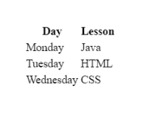 </tr>

<tr>

<td>Monday</td>

<td>Java</td>

</tr>

<tr>

<td>Tuesday</td>

<td>HTML</td>

</tr>

<tr>

<td>Wednesday</td>

<td>CSS</td>

</tr>

</table>

</body>

</html>

Output:

### Table Border

* We can add border to table with **border** attribute in table tag like example below.  
  <table border="number">

**⚠️Avoid:**

* The border attribute is not supported in HTML5. Use CSS instead.

<!DOCTYPE html>

<html>

<body>

<h1>Course Program</h1>

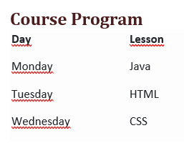 <table border="1">

<tr>

<th>Day</th>

<th>Lesson</th>

</tr>

<tr>

<td>Monday</td>

<td>Java</td>

</tr>

<tr>

<td>Tuesday</td>

<td>HTML</td>

</tr>

<tr>

<td>Wednesday</td>

<td>CSS</td>

</tr>

</table>

</body>

</html>

Colspan Attribute

* We can span two or more columns by using the colspan attribute like example below.  
  < td colspan="2" >Java< /td >

<!DOCTYPE html>

<html>

<body>

<h1>Course Program</h1>

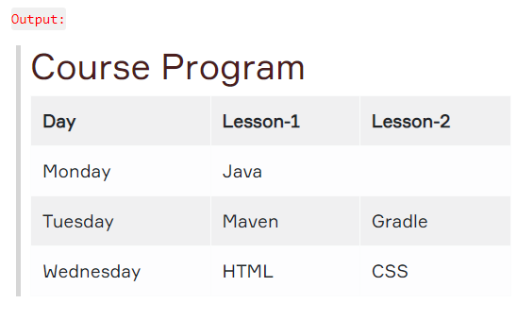 <table border="1">

<tr>

<th>Day</th>

<th>Lesson-1</th>

<th>Lesson-2</th>

</tr>

<tr>

<td>Monday</td>

<td colspan="2">Java</td>

</tr>

<tr>

<td>Tuesday</td>

<td>Maven</td>

<td>Gradle</td>

</tr>

<tr>

<td>Wednesday</td>

<td>HTML</td>

<td>CSS</td>

</tr>

</table>

</body>

</html>

Rowspan Attribute

* We can span two or more rows by using the rowspan attribute like example below.  
  < td rowspan="2" >Java< /td >

<!DOCTYPE html>

<html>

<body>

<h1>Course Program</h1>

<table border="1">

<tr>

<th>Day</th>

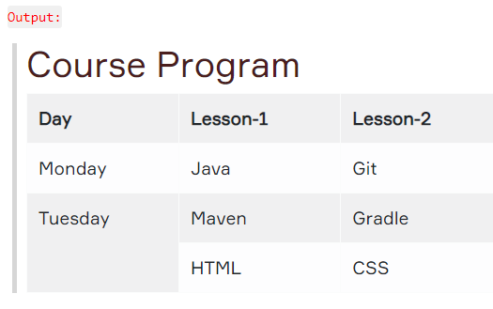 <th>Lesson-1</th>

<th>Lesson-2</th>

</tr>

<tr>

<td>Monday</td>

<td>Java</td>

<td>Git</td>

</tr>

<tr>

<td rowspan="2">Tuesday</td>

<td>Maven</td>

<td>Gradle</td>

</tr>

<tr>

<td>HTML</td>

<td>CSS</td>

</tr>

</table>

</body>

</html>

Align Attribute

* 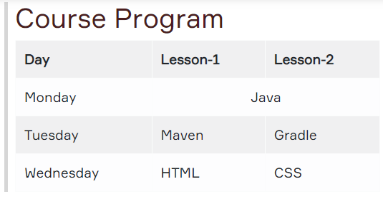To change table or cell position, we can use the align attribute inside <table> tag or <td> tag.  
  <td align="center">java</td >

<!DOCTYPE html>

<html>

<body>

<h1>Course Program</h1>

<table border="1">

<tr>

<th>Day</th>

<th>Lesson-1</th>

<th>Lesson-2</th>

</tr>

<tr>

<td>Monday</td>

<td align="center" colspan="2" >Java</td>

</tr>

<tr>

<td>Tuesday</td>

<td>Maven</td>

<td>Gradle</td>

</tr>

<tr>

<td>Wednesday</td>

<td>HTML</td>

<td>CSS</td>

</tr>

</table>

</body>

</html>

View the Lesson (HTML Images)

The < img > Tag

* We can improve the design of a web page by adding images.
* The <img> tag is used to define an image.
* The <img> tag is empty. It means that it does not have a closing tag.
* The **src** attribute allows us to specify the web address (URL) of the image and it is mandatory.

# **HTML Image**

https://clarusway.com/wp-content/uploads/2019/12/cw_sonk%C3%BC%C3%A7%C3%BCk2.png

https://clarusway.com/wp-content/uploads/2019/12/cw_sonk%C3%BC%C3%A7%C3%BCk2.png

<!DOCTYPE html>

<html>

<body>

<h1>HTML Image</h1>

<img src="https://lms.clarusway.com/theme/image.php/boost/theme_boost/1581703952/Clarusway-LOGOTYPE">

</body>

</html>

The alt attribute

* The **alt** attribute is used to provide an alternate text for an image in case the image fails to load on a web page or it is not supported by the browser, etc.
* Moreover, Visually impaired users browse the web via screen reading software. the screen reading software can read the text inside an alt attribute for impaired users.
* 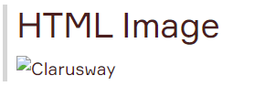We should add alt attribute to the image tag just like the src attribute.

<!DOCTYPE html>

<html>

<body>

<h1>HTML Image</h1>

<img src="https://clarusway.comt/uploads/2019/11/ClaruswayLOGO_png100_326.png" alt="Clarusway">

</body>

</html>

The width and height attributes

* The width and height attributes are used to resize images.

<!DOCTYPE html>

<html>

<body>

<h1>HTML Image</h1>

<h2>Clarusway</h2>

<img src="https://clarusway.com/wp-content/uploads/2019/11/ClaruswayLOGO_png100_326.png" alt="Clarusway" width="100%" height="auto">

 </body>

</html>

The border attribute

* By default, an image has no borders.
* To add a border around the image, we can use border attribute.

<!DOCTYPE html>

<html>

<body>

<h1>HTML Image</h1>

<img src="https://clarusway.com/wp-content/uploads/2019/12/cw_sonk%C3%BC%C3%A7%C3%BCk2.png" alt="Clarusway" border="2px">

</body>

</html>

The < a > Tag

* One of the advantages of HTML , is the ability to link to other web pages.
* The <a> element and including text is used to define a link.

<!DOCTYPE html>

<html>

<body>

<h1>HTML Links</h1>

<a>Welcome clarusway</a>

</body>

</html>

# **HTML Links**

Welcome Clarusway

### The href Attribute

* Technically, we didn't complete the HTML link.
* We need href attribute inside opening <a> tag to specify which page we want to link.
* The **href** attribute defines the address of the link.

<!DOCTYPE html>

<html>

<body>

<h1>HTML Links</h1>

<a href="http://clarusway.com/">Welcome clarusway</a>

</body>

</html>

Output:

# **HTML Links**

[Welcome clarusway](http://clarusway.com/)

### The target Attribute

* The target attribute is used to specify how a link should open.
* In order to open link in a new page, the target attribute requires a value of _blank.
* We should add the target attribute inside opening <a> tag like href attribute.

<!DOCTYPE html>

<html>

<body>

<h1>HTML Links</h1>

<a href="http://clarusway.com/" target="_blank">Welcome clarusway</a>

</body>

</html>

Output:

# **HTML Links**

[Welcome clarusway](http://clarusway.com/)

Image as a Link

* We can use an image as a link in HTML.
* For this, it is enough to put an <img> tag between opening and closing <a> tag.

<!DOCTYPE html>

<html>

<body>

<h1>HTML Links</h1>

<a href="http://clarusway.com/" target="_blank"><img src="https://drive.google.com/open?id=1u4ycHASa7sVNknCxXeca2dwD7l9Va0PK" alt="A lighthouse" width="50%" height="auto"></a>

</body>

</html>

Output:

# A lighthouse**HTML Links**

## HTML Interview Questions

## What do you mean by HTML?

HTML is known as Hypertext Markup Language. This Language is used for World Wide Web. It’s a standard Language which is used for creating the web pages.

## What are the parts of the HTML page?

Basically, there are two parts of the web pages: Content and Tags which are responsible for the format of an HTML page.

## What do you mean by Tags?

In HTML page content is placed between the Tags which are basically responsible for the formatting of the page. Tags are written between less than symbol (<) and greater than (>) symbol.

## Do all HTML tags are written in a pair?

This is the most common HTML Interview Questions asked in an interview. No, there are some HTML tags are present which can be used as single.

## What are the list types available in HTML?

The common list type are available in HTML are given below:  
– Ordered list  
– Unordered list  
– Definition list  
– Menu list  
– Directory list

## Give the example for putting a comment in the HTML page?

<!—Text for comment ->

## How to apply Hyperlink in an HTML page?

We can use <ahref> tag for HTML page. For eg: <ahref> Text </a>

## How to change the font colour in the HTML page?

<font color=”color”>…</font>

## How to write the paragraph in the HTML page?

For the paragraph tag <p> text you want to show the paragraph </p> will be used.

## Which browser supports the HTML5?

Google Chrome, Apple Safari, Mozilla Firefox, and Opera all support most of the HTML5 features.

## What are the different types of heading format supported by HTML?

HTML heading is use to highlight the content of HTML document. the heading tags which are used in HTML are <h1> to <h6>.

## How to create a table in HTML?

By using <table> tag we create the table in HTML.

## What are the frames?

By using frames we can make the navigation of the site easier.

## What is HTML5?

HTML5 is the fifth version of [HTML language](https://www.educba.com/what-is-html/) and it is the currently [running version of HTML](https://www.educba.com/versions-of-html/).

## Which new tags are included in the HTML5?

<video> and <audio> are the new tags which are introduced in the HTML5. They are basically used as a replacement of flash player and Silverlight to play multimedia items in the web pages.

## What is the Canvas element in the HTML?

For representing charts, 2D images, graphs on the web page we use Canvas element.

## What are the storage types of HTML5?

Two storage type of HTML5 are:  
**Session Storage**– It will store the data related to the current.  
**Local Storage-** In this data will not be erased when the browser is closed

## How can we get the geographic position of a user in HTML5?

By using Geolocation API we can retrieve the location of the user.

## What do you mean by HTML attribute?

Additional information given with the elements is known as an attribute. For Eg  
<font size=”10” color=”red”>

## How we use JavaScript with HTML?

By using script tag we can use JavaScript with HTML. For Eg:  
<script>  
document.getElementById(“demo”).innerHTML = “Hello JavaScript!”;  
</script>

## What is the Get and Post Method?

GET s use to request the data from server and POST is used for submitting the data to a server.

## What is SPAN tag is used for?

Span is used for formatting elements in the SPAN block. It is used to select inline text.

## What does HTML Stands for?

HTML Stands for **Hypertext Markup Language**. This language is basically used for creating web applications and also for web pages as well. It is a standard markup language with cascading style sheets and JavaScript which form a triad for WWW i.e. worldwide Web.HTML came into existence in 1980 when a great computer professor Sir Tim Berners Lee (a contractor and author of HTML) proposed an idea in CERN, to basically sharing and using documents. So in this way, a great language came into existence.

## What is the XHTML?

[XHTML](https://www.onlineinterviewquestions.com/xhtml-interview-questions/) means Extensible Hypertext Markup Language, which is basically a part of Family of XML markup language. It usually extends the most popularly used HTML i.e. Hypertext Markup Language, the pages in which the web pages are formulated.

## What does DOCTYPE mean?

DOCTYPE or Document Type Declaration is a type of instruction which usually works in association with particular SGML or [**XML**](https://www.onlineinterviewquestions.com/xml-interview-questions/) documents basically. Let us take an example to understand it more thoroughly, for example, A Web page with a document type definition i.e. DTD is the best to understand. In a well serialized and a proper form of the document, It manifests and also the contribution of it is a lot as a short string of markup that usually conforms to a particular syntax.

## What new features were added to HTML5?

It introduced several semantic components, which refers to the elements that express the meaning. Some of the new semantic components are <header>, <footer>, <section>, and <article>. That means they are not in simple containers, but they tell the browser more about their contents.

There are additional form element types such as “Number”, “Date”, “Calendar” and “Range”. Video and audio elements are included, and new graphic elements like <svg> and <canvas> have been added.

## What is SVG element?

SVG is followed by the XML format; It has scalable vector graphics used to create vector graphics with interactive and animated support.

Resolution is independent of SVG because it does not lose its size or rearrange its quality.

## What is the difference between directory and menu lists and unordered lists?

The main difference is that directory and menu lists do not have attributes to change bullet styles.

**Tell me two advantages of HTML5 web storage**

Two main advantages of HTML5 Web Storage are:

* It can save up to 10 MB data, which is definitely more than what cookies are.
* Web Storage Data can not be changed with HTTP request. It helps to increase the performance of the application.

## Explain five new input types provided by HTML5 for shapes?

The following important, new data types are provided in HTML5:

Date: This allows the user to select a date.

Data Time-Local: This input type allows user time and time to select a date and time.

Date: This input type allows user time and time to select a time and time.

Month: It helps the user choose a month and year

## What is Semantic Elements?

Semantic elements expresses its meaning for the web browser and developer.

Eg: Header , Footer

## A developer has been given an assignment to create a webpage for a shopping application. Which of the below language he need to learn to create the basic structure of the webpage?

markup.

## A developer wants to create a HTML page. In which part of the code he can keep the information about the page?

head section.

## Is it possible to nest HTML lists?

 Yes

## Webpage can be linked to itself by creating _____________.

Bookmark